The **Zscaler Test – AnyConnect Profile** – Switcher utility was created to allow Macs laptops to disconnect from the VPNs while maintaining internet connectivity in support of Zscaler Pilot Phase.  The utility has been made available to your Mac laptop for install via Self Service.

**Step 1 -**  Visit **Self Service** and install **AnyConnect Switchable (On/Off) Profile**

**Step 2 -**  Verify you can disconnect From **AnyConnect** and access internet sites.

**Note:** Auth failures to O365 and other CFPB resources are expected at this point.

**Step 3 -** Visit **Self Service** and install **Zscaler Test** Install.

The **Zscaler** client should open automatically. If prompted to log in, choose **certificate** if you have a PIV card. Otherwise, use username and password.

**Note:** You may see zero, one, or both of the screens below:

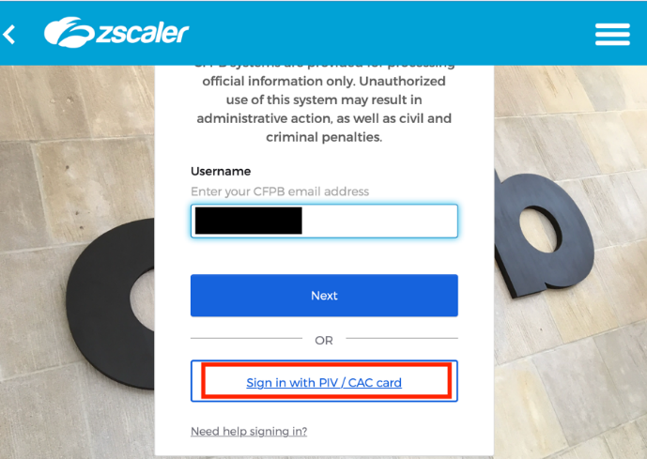

To Log in with your PIV certificate, enter the PIN number as shown here.

When authenticated, the Zscaler app will show in the menu bar and there will be indications in the **Private Access** and **Internet Security** sections of the application.

Menu bar:



**Private Access**

**Internet Security**

If you have any additional questions or comment on the test script please, please submit a RITM and assign the task to the **Zscaler Pilot** Assignment group.